AURA Official Website Structure & Content Architecture

Global Header Navigation & Utility Bar

. Main Navigation Bar
- Brand Identity: AURA Logo + Full Title (Alliance for Understanding Recovery & Awareness)
- Navigation Links: Home | About Us | Program and Event | Community | Resource | Get Involved | Contact Us

Section 1: Home Page

1. Hero Section
- Main Headline: Mental Wellbeing for All!
- Subheadline: AURA creates safe spaces for open conversation, recovery support, and mental wellness awareness across Ethiopian communities. We break stigma and foster healing through peer circles, public dialogues, and community care.
- Action Pathways (Three Primary Buttons):
  - Resources (Links to downloadable toolkits, self-care guides, and referral directories)
  - Upcoming Events (Links to community circles, workshops, and stakeholder forums)
  - Join the Community (Links to Telegram hub @AURA_MHP and peer group onboarding)
- Hero Visual: Authentic photography from local community dialogue sessions in Addis Ababa.
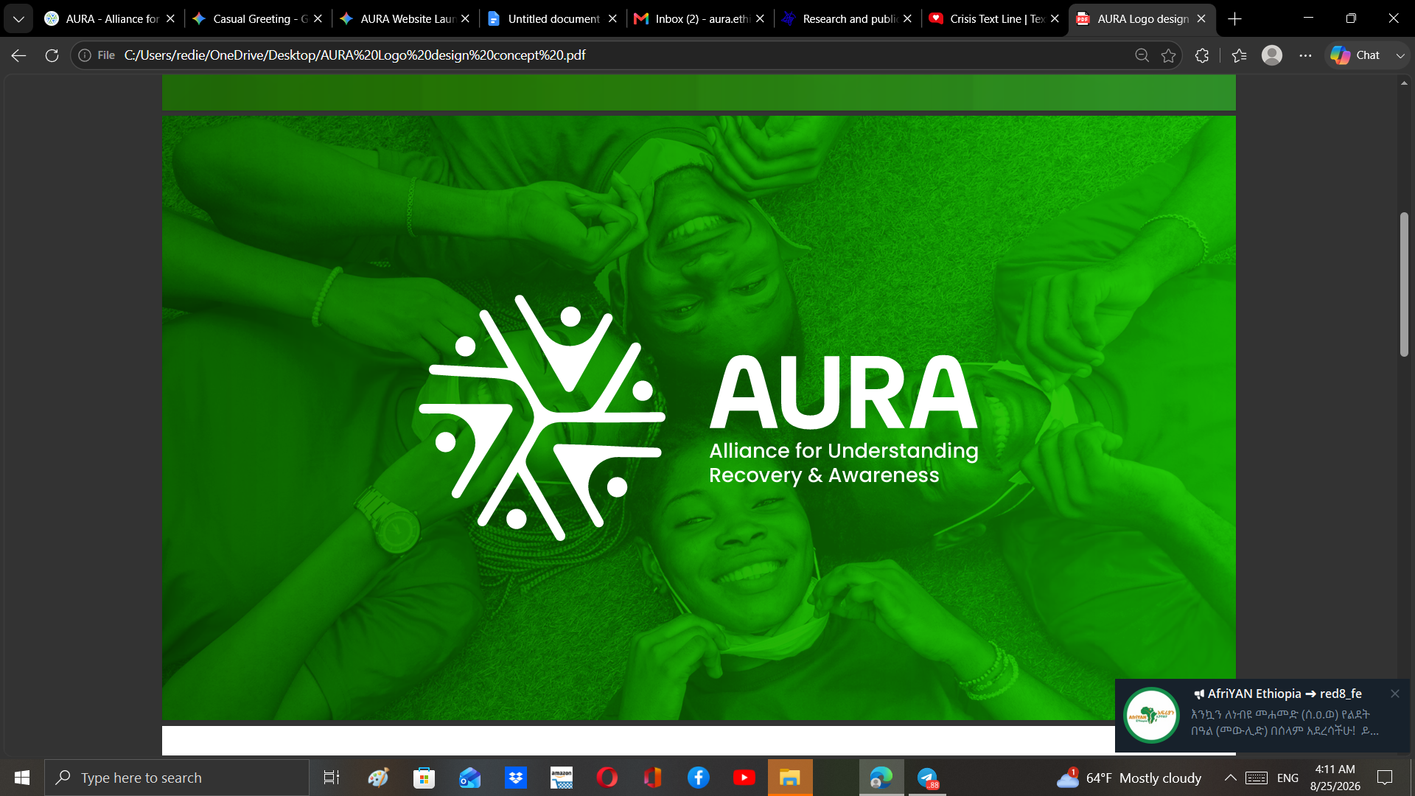

2. Impact Counter Bar
Metric | Description
1,000+ | People Connected across networks
100+ | Individuals Supported directly
80+ | Community Conversations Hosted

3. Core Support Pillars
- Safe Support Pathways: Guided listening, peer support circles,
- Community Understanding: Open public dialogues, awareness campaigns, and community forums that combat mental health stigma in Ethiopia.
- Practical Resources: Culturally adapted tools, stress management guides, and educational materials tailored for students, families, and professionals.

Section 2: About Us

Mission, Vision, and Values
- Our Mission: To create accessible, culturally attuned safe spaces for mental health support and stigma reduction by empowering youth, leveraging digital innovation, and driving multi-stakeholder action.
- Our Vision: A society where mental wellness is understood, valued, protected, and accessible to all—free from stigma and exclusion.
- Core Values:
- (5-card grid layout with icons representing each core value below the Mission & Vision section. )
Empathy & Respect (Compassionate, Stigma-Free Care)
Inclusivity & Accessibility (Equitable Outreach for All)
Integrity & Transparency (Ethical & Accountable Governance)
Community-Centered Care (Safe Spaces & Peer Resilience)
Strategic Collaboration (Partnerships for Systemic Impact)

Governance & Legal Compliance
Official Registration & Compliance: AURA (Alliance for Understanding Recovery & Awareness) is officially registered as an Ethiopian Civil Society Organization (CSO) under Proclamation No. 1113/2011. We adhere to national governance regulations and international non-profit best practices to ensure full operational transparency and impact accountability.
HEADER: Our Leadership & Governance
SUB-HEADER: Guided by vision, grounded in accountability, and driven by community impact.

Profile Card | Name & Title | Bio Copy
Founder | Rediet Feleke  Founder & Executive Director | Rediet Feleke is the Founder and Executive Director of AURA. As the primary visionary behind the initiative, she directs organizational strategy, cross-sector partnerships, and community program execution to advance accessible, stigma-free mental health support across Ethiopian communities
Co-Founder | Simret Gashaw | Simret Gashaw is a Co-Founder of AURA, driving strategic outreach, community engagement, and program development. She plays a key role in shaping AURA's foundational mission, expanding support networks, and fostering safe, inclusive spaces for mental health awareness.
Co-Founder | Meseret Gossa | Meseret Gossa is a Co-Founder of AURA, contributing to organizational vision, initiative design, and stakeholder collaboration. She works closely with the founding team to build sustainable pathways for mental health advocacy and community recovery.

The Board
Name & Title | Read More
Prof. Mubarek Abera Mengistie  Board Chairman | Full Professor of Mental Health and Nutrition with over 15 years of experience in academia, health system leadership, and international research collaborations. Lead consultant for national strategic initiatives (UNICEF/MoH) and widely published author. He provides overall board stewardship, focusing on institutional strategy, academic alignment, research integrity, and senior advisory leadership
Ms. Rediet Dadi Tafa  Board Member | Senior Psychologist, Training Director, and Psychotherapist with over 5 years of experience leading nationwide personal development and psychological training initiatives. She leverages her background in trauma-focused therapy and capacity building to ensure our initiatives deliver measurable behavioral change and community impact.
Asst. Prof. Anteneh Fikrie Tekola  Board Member | Assistant Professor of Public Health, Director of Research & International Partnerships at Bule Hora University, external PhD candidate (Maastricht University), and PLoS ONE editor. He ensures our public health and research methodologies are ethically sound, rigorous, and positioned for international institutional partnerships.
Dr. Tamrat Tefera Ali  Board Member | Assistant professor of Psychiatry, Certified Psychotherapist (Toronto University), and specialist in child and adolescent mental health. He provides strategic guidance to ensure all therapeutic, training, and community outreach programs meet high clinical standards.
Ms. Ruth Tesfaye Tegen  Board Member | Dedicated advocate for youth empowerment and community-driven social initiatives. She focuses on creating inclusive, accessible spaces that empower young people to lead mental health advocacy efforts

Photos

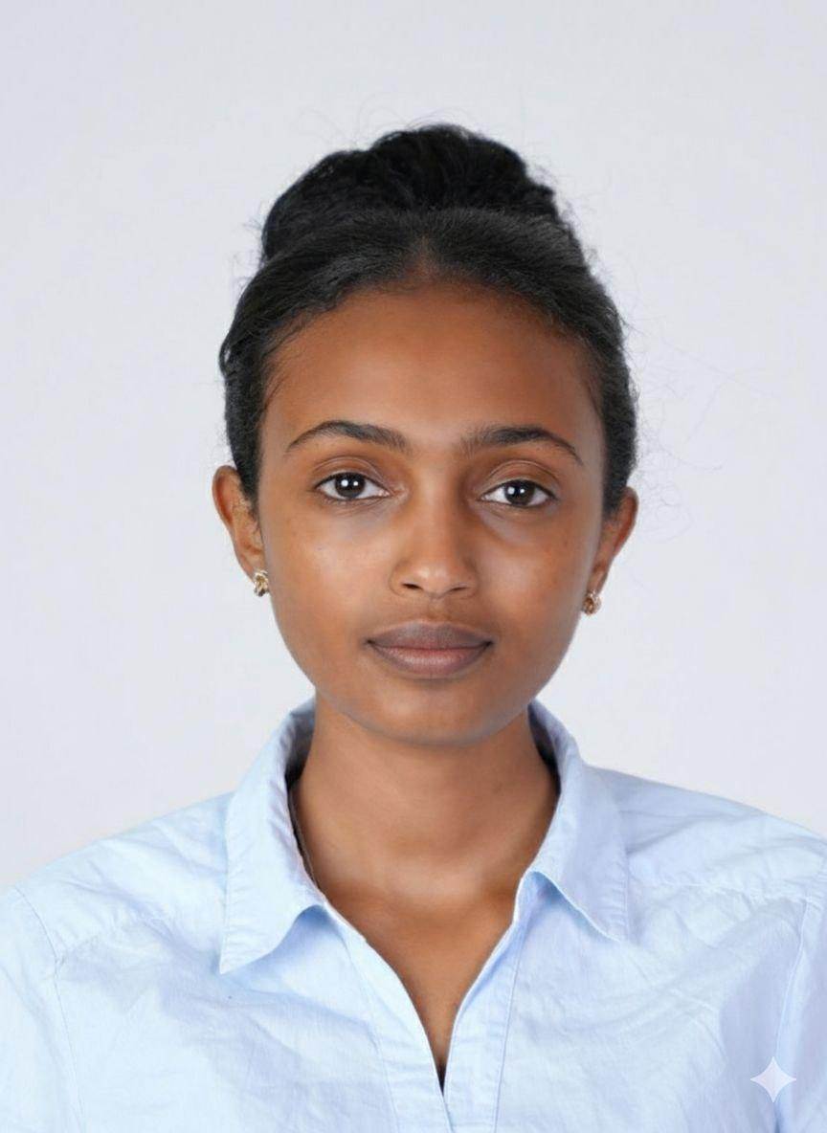 | [Name/Title Placeholder]
 | [Name/Title Placeholder]
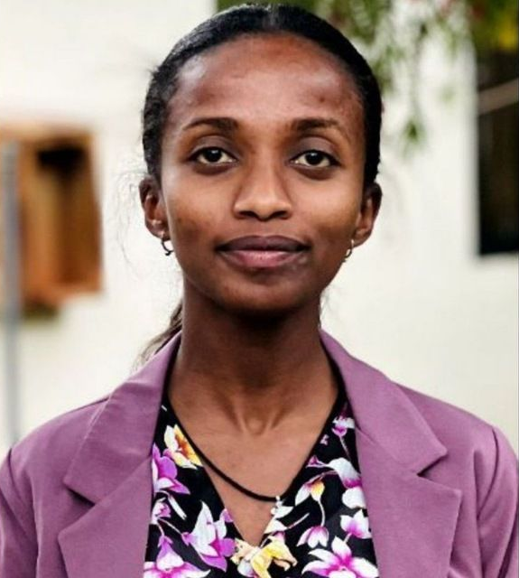 | [Name/Title Placeholder]
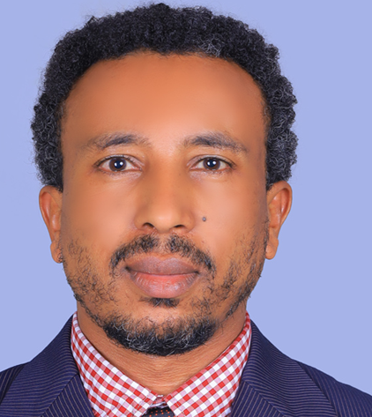 | [Name/Title Placeholder]
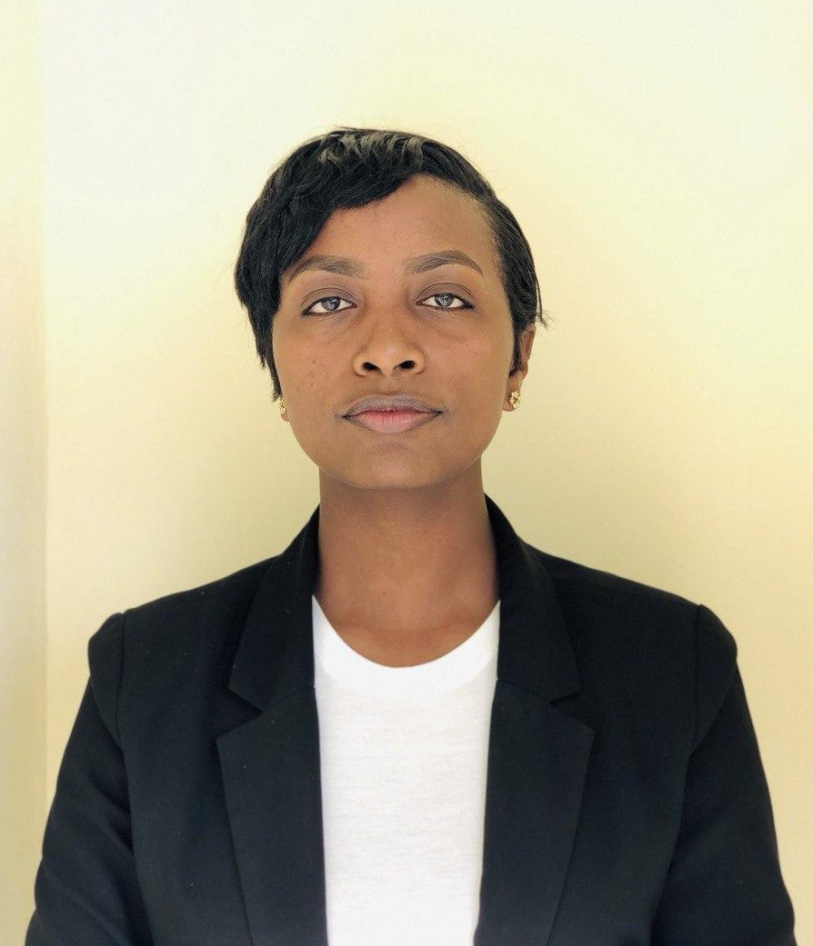 | [Name/Title Placeholder]
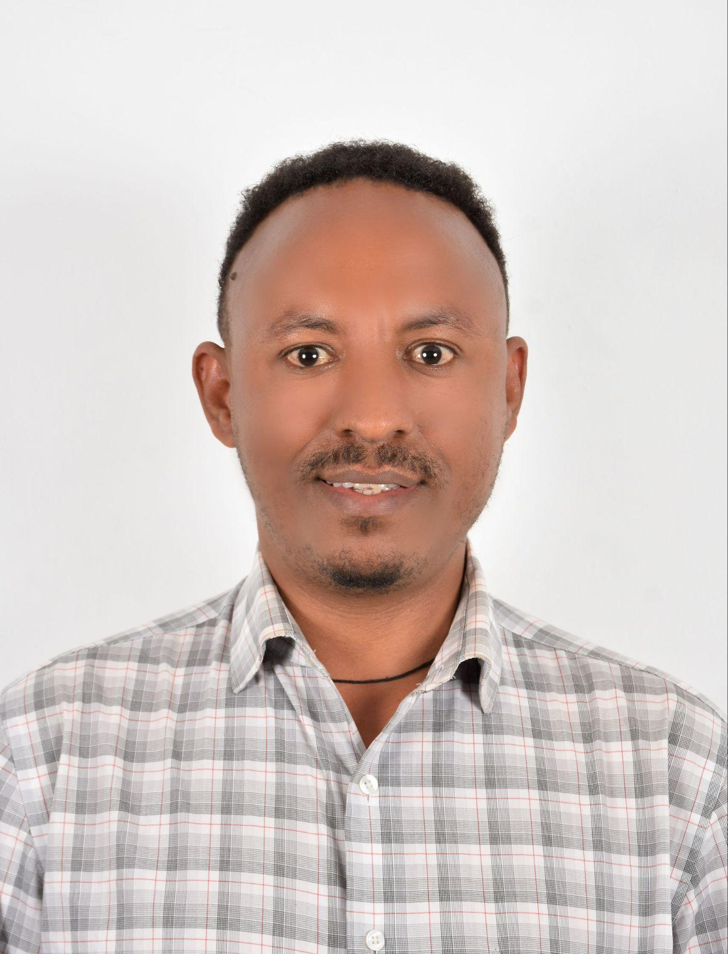 | [Name/Title Placeholder]
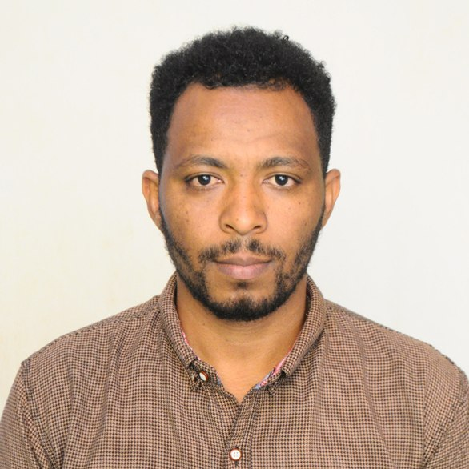 | [Name/Title Placeholder]
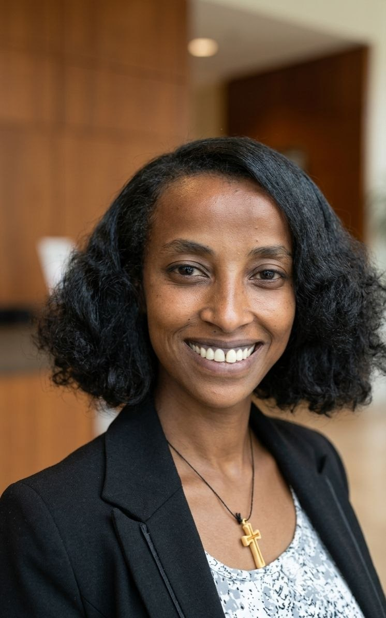 | [Name/Title Placeholder]

Section 3: Program and Event
Leave what you have done already and add icons for the following ongoing programs
- Weekly Family Time
- Virtual Trainings
- In-Person trainings
- Events

Section 4: Community

As it is plus…Sign in/up option to access (let the descriptions be as they are)

Safety & Code of Conduct
- Strict Confidentiality: What is shared in AURA spaces stays in AURA spaces.
- Non-Judgmental Respect: Valuing every individual's unique story without bias.
- Empathetic Listening: Focus on active support rather than unsolicited advice.
- Safety First: Immediate warm handoffs for acute clinical needs.

Section 5: Resource

You can leave as it is … but bring it on the navigation bar
Sign in/up for access button

Section 6: Get Involved
Leave it as it is for now and add
- Membership: How to become a member, membership benefits, membership tiers, Register Here…..(Application is closed for Now!)

Section 7: Contact Us & Global Footer

1. Contact & Location Details
- Physical Location: Bole Sub-City, Addis Ababa, Ethiopia
- Official Email: contact@auramentalhealth.com
- Telegram Community Hub: @AURA_MHP

2. Safety & Crisis Disclaimer
Important Emergency Notice: AURA provides community awareness, peer support circles, and educational resources. We are not an emergency medical service or a psychiatric crisis clinic. If you or someone you know is experiencing an immediate life-threatening crisis or severe emotional distress, please contact national emergency services or visit the nearest hospital psychiatric department immediately.

National Emergency Crisis Helpline: Call 952

Global Footer Structure
Column 1 | Column 2 | Column 3 | Column 4
AURA Identity & CSO Standing  Registered Ethiopian CSO under Proclamation No. 1113/2011.  Short statement highlighting CSO registration under Proclamation No. 1113/2011 and community mission.  • Contact Us Button (High contrast)  • Icons: Facebook, Instagram, X, LinkedIn, Email | Quick Links  About  Become a Member  Blog  Fund Us  FAQ | Contact Info  Bole, Addis Ababa  contact@auramentalhealth.com  @AURA_MHP | Newsletter  Subscribe to our newsletter  [your.email@example.com ]  [ First name ]  [ Last name ]  • Submit Button (Full-width accent)  "We value your privacy and will never send irrelevant information."
© 2026 Alliance for Understanding Recovery & Awareness (AURA). All Rights Reserved.
